

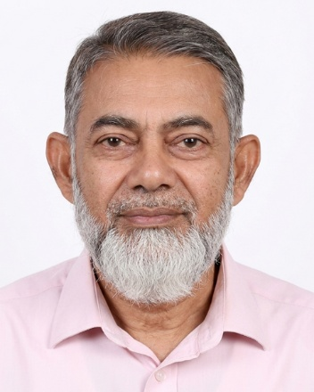
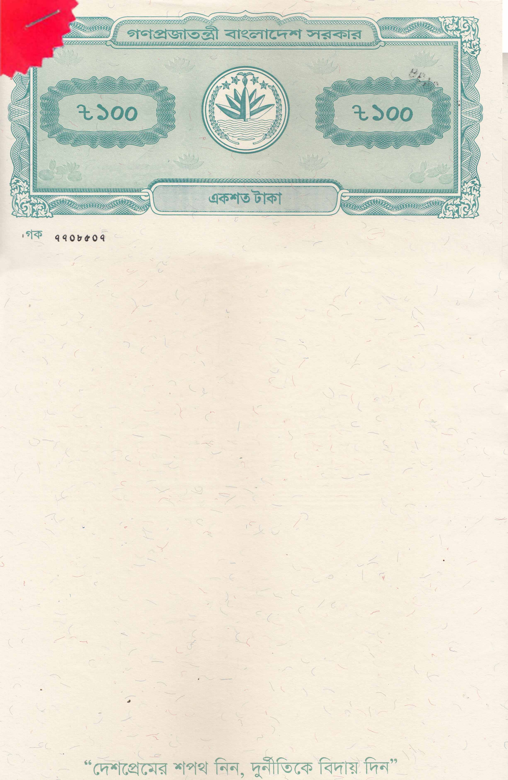

BEFORE THE NOTARY PUBLIC DHAKA, BANGLADESH
GIFT DECLARATION / AFFIDAVIT

I, MD SHAHEED LATEEF, Father: Md Abul Mannan, Mother: Shiria Begum, Address: 54/3/A, North Road, Bhuter Goli, Kalabagan, New Market-1205, Dhaka. Religion: Islam, Nationality: Bangladeshi, National ID No- 507 324 5887, Profession: Teacher, do hereby solemnly affirm and declare the following that:
- That ZAIMA ZOHRA, Date of birth: 29 March 2001, Passport No: A08826349 is my daughter, and I maintain a deep love and affection for her.
- That on the occasion of her marriage, held on November 7, 2025, I have voluntarily gifted her a sum of BDT 41,60,000/- (Forty-One Lac Sixty Thousand Taka only).
- That this gift is made out of my natural love and affection for my daughter and is given without any coercion, undue influence, or pressure from any party.
- That the said amount has been handed over to her, and she has accepted the gift.
- That I am a lawful taxpayer, and this amount is gifted from my own accumulated savings/income.
- That from the date of the gift, my daughter, ZAIMA ZOHRA, is the absolute owner of the said amount, and I or my legal heirs shall have no claim or right over it in the future.



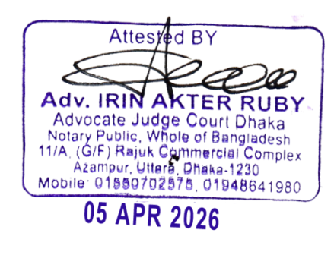


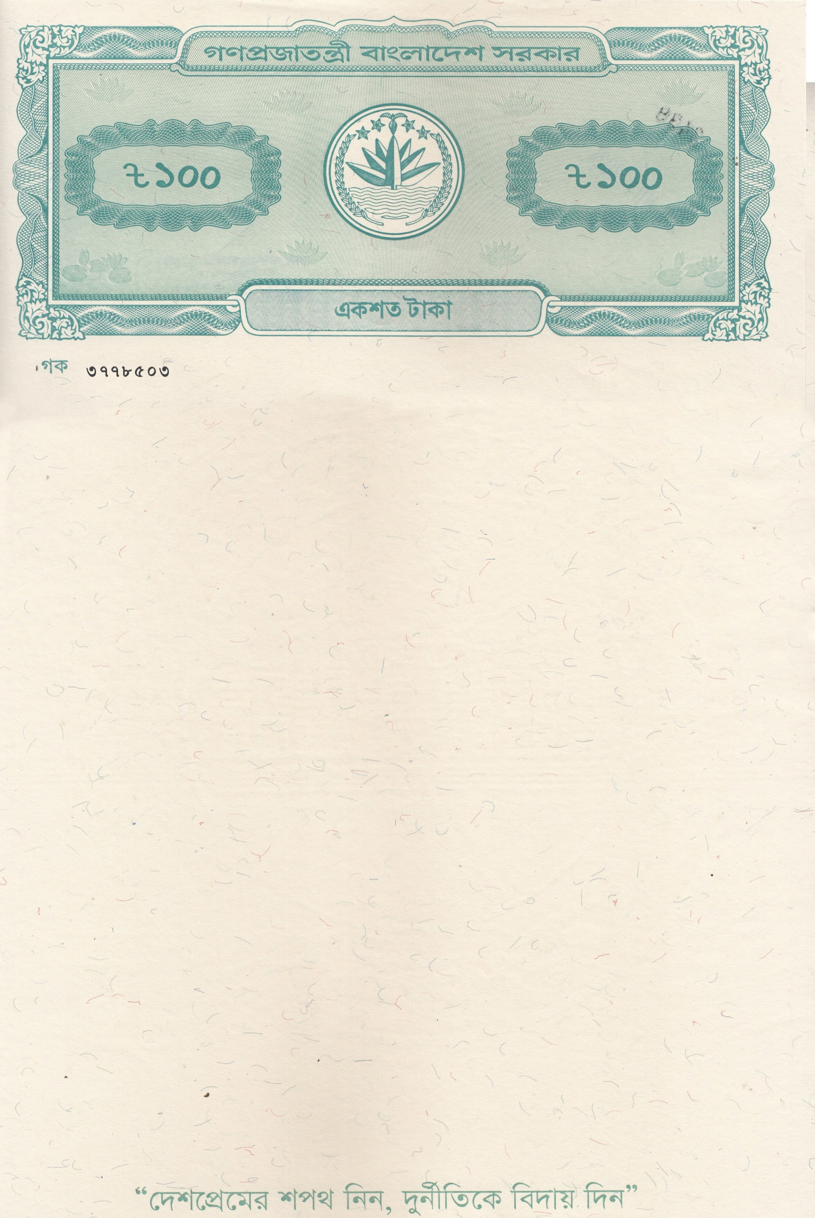

I solemnly affirm that all the above statements are true and correct to the best of my knowledge and belief. In witness whereof, I have executed ther Affidavit of Financial Support before the Notary Public in Dhaka, Bangladesh.

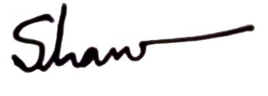

MD SHAHEED LATEEF
(Signatures of Deponents)

The deponent is personally known to me, has been duly identified, and has signed ther affidavit in my presence.

